**Auto Scaling:**

1. It is used to create scaling plans to launch or Terminate EC2 instances dynamically based on utilization to provide High availability and cost management.
2. **Hear is 2 steps:**
3. **Create launch configuration**

* Launch configuration is similar to EC2 configuration like selecting AMI, instance type, key pair and security groups.
* Launch configuration can’t be modified after creation and needs to be created new if any modification required

1. **Create Auto scaling group**

* Contains a collection of Amazon EC2 instances and we need to define launch configuration, AZ, Min and Max capacity of instances to launch based on health check.

1. **Hear is 2 types of scaling**
2. Horizontal scaling

Scale-In and scale-out (based on load need to launch new instance)

1. Vertical scaling

Scale-Up and Scale-down (Increasing instance configuration like RAM, Disk, N/W, CPU)

**Termination policy:**

Which AZ is having **most instances.**

**Oldest launch configuration**

**Closest to the next billing hour**

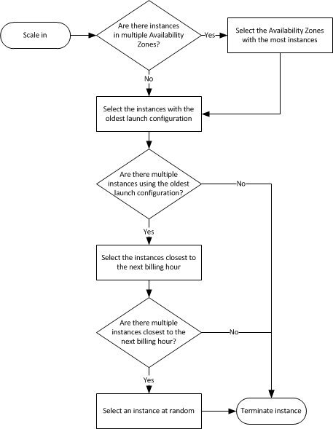

**Deleting:**

**First delete ASG.**

**Second Delete Launch configuration**